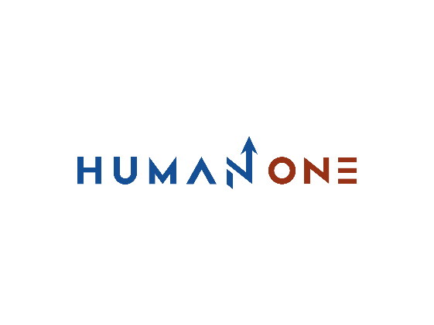

Services

Expertise

**EN**

**FR**

Get in touch

Company

Who We Are

Partnership

Technology Office



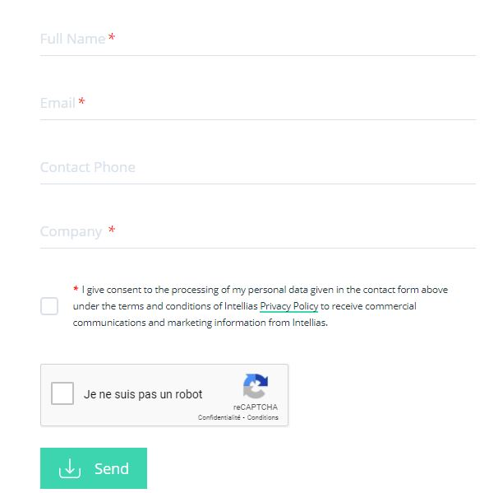

HumanOne is a supplier of software engineering and digital consulting services, delivering solutions to Fortune 500 companies and helping leading technology innovators build products in a variety of domains. HumanOne is looking for partners to create a solid global network for our organization.

We are eager to collaborate with a partner whose existing network can bring new revenue for HumanOne business and maximize accounts’ growth. Explore our partnership opportunities, and let’s grow faster together.

# **Interested in our Partnership Program?**

Please fill the form and HumanOne partnership manager will contact you back shortly

# **Partner with Us**

## 

